**FOURIER SERIES REPRESENTATION OF CONTINUOUS TIME SIGNALS**

**LAB # 10**



**CSE301L Signals & Systems Lab**

Submitted by: **Shah Raza**

Registration No: **18PWCSE1658**

Class Section: **B**

“On my honor, as a student of University of Engineering and Technology, I have neither given nor received unauthorized assistance on this academic work.”

Student Signature: ______________

Submitted to: **Engr. Durr-e-Nayab**

Sunday, August 30th, 2020

**Department of Computer Systems Engineering**

**University of Engineering and Technology, Peshawar**

**Lab Objectives:**

Objectives of this lab are as follows:

* Fourier Series Representation of Continuous Time Period Signals
* Convergence of CT Fourier Series
* Properties of CT Fourier Series
  + Linearity
  + Time Shifting
  + Frequency Shifting
  + Time Reversal
  + Time Scaling

**Task # 1:**

In the above example, ak’s are chosen to be symmetric about the index k=0, i.e. ak = a‐k. Select new ak’s on your own to alter this symmetry and form the new signal. What do you observe? Is x(t) a real signal when coefficients are not symmetric?

**Observation:**

x(t) is a real signal when coefficients are not symmetric.

**Code:**

t = -3:0.01:3; % duration of signal

% dc component for k=0

x0 = 1;

% first harmonic components for k=-1 and k=1

x1 = (1/4)*exp(j*(-1)*2*pi*t)+(1/8)*exp(j*(1)*2*pi*t);

y1 = x0 + x1; % sum of dc component and first harmonic

% second harmonic components for k=-2 and k=2

x2 = (1/2)*exp(j*(-2)*2*pi*t)+(1/4)*exp(j*(2)*2*pi*t);

y2 = y1 + x2; % sum of all components until second harmonic

% third harmonic components for k=-3 and k=3

x3 = (1/3)*exp(j*(-3)*2*pi*t)+(1/6)*exp(j*(3)*2*pi*t);

x = x0 + x1 + x2 + x3; % sum of all components until third harmonic

figure;

subplot(3,2,1);

plot(t,x1);

axis([-3 3 -2 2]);

title('x1(t)');

subplot(3,2,2);

plot(t,y1);

axis([-3 3 -0.2 2]);

title('x0(t)+x1(t)');

subplot(3,2,3);

plot(t,x2);

axis([-3 3 -2 2]);

title('x2(t)');

subplot(3,2,4);

plot(t,y2);

axis([-3 3 -1 3]);

title('x0(t)+x1(t)+x2(t)');

subplot(3,2,5);

plot(t,x3);

xlabel('t');

axis([-3 3 -1 1]);

title('x3(t)');

subplot(3,2,6);

plot(t,x);

xlabel('t');

axis([-3 3 -1 4]);

title('x(t)=x0(t)+x1(t)+x2(t)+x3(t)');

**Output:**

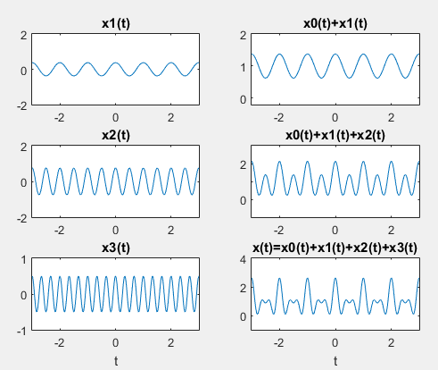

**Task # 2:**

A discrete‐time periodic signal x[n] is real valued and has a fundamental period of N = 5. The non‐zero Fourier series coefficients for x[n] are

a0 =1,a2 = a-2 = ej pi/4, a4 = a-4 = 2ej pi/3

Express x[n] as a linear combination of given coefficients.

**Problem Analysis:**

Change the coefficients of a0 to 1 and a2, a-2 equal to ej pi/4 and a4, a-4 equal to 2ej pi/3

**Code:**

t = -5:0.01:5; % duration of signal

% dc component for k=0

x0 = 1;

% second harmonic components for k=?2 and k=2

x2 = (exp(j*(pi/4)))*exp(j*(-2)*(2*pi/5)*t)+(exp(j*(pi/4)))*exp(j*(2)*(2*pi/5)*t);

y2 = x0 + x2; % sum of all components until second harmonic

% fourth harmonic components for k=?4 and k=4

x4 = (2*exp(j*(pi/3)))*exp(j*(-4)*(2*pi/5)*t)+(2*exp(j*(pi/3)))*exp(j*(4)*(2*pi/5)*t);

x = x0 + x2 + x4; % sum of all components until fourth harmonic

figure;

subplot(3,1,1);

plot(t,x2);

title('x2(t)');

subplot(3,1,2);

plot(t,x4);

title('x4(t)');

subplot(3,1,3);

plot(t,x);

title('x0(t)+x2(t)+x4(t)');

**Output:**

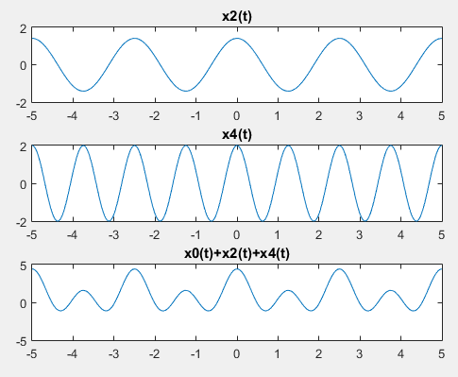

**Task # 3:**

Considering the FS coefficients plot given below, what do you observe happens to the envelope of the coefficients when T1 is reduced from 1/4 to 1/16 with constant time period T?

**Observation:**

As T1 is changed from 1/4 to 1/16 and we observe that the frequency of the wave decreases and time period increases.

**Code:**

k = -15:15; %number of square wave coefficients

T = 1; %time period of square wave

T1 = 1/4; %duty cycle of square wave

ak1 = sin(k*2*pi*(T1/T))./(k*pi); %square wave Fourier series coefficients

% Ignore the "divide by zero" warning that happens

% because k in the denominator hits 0. We will now do

% a manual correction for a0 ?> ak1(16)

ak1(16) = 2*T1/T;

subplot(3,1,1);

stem(k,ak1,'filled');

ylabel('ak');

title('FS Coefficients for Periodic Square Wave (T=1, T1=1/4)');

T1 = 1/8;

ak2 = sin(k*2*pi*(T1/T))./(k*pi);

ak2(16) = 2*T1/T; % Manual correction for a0 ?> ak2(16)

subplot(3,1,2);

stem(k,ak2,'filled');

ylabel('ak');

title('FS Coefficients for Periodic Square Wave... (T=1, T1=1/8)');

T1 = 1/16;

ak3 = sin(k*2*pi*(T1/T))./(k*pi);

ak3(16) = 2*T1/T; % Manual correction for a0 ?> ak3(16)

subplot(3,1,3);

stem(k,ak3,'filled');

xlabel('k');

ylabel('ak');

title('FS Coefficients for Periodic Square Wave (T=1, T1=1/16)');

**Output:**

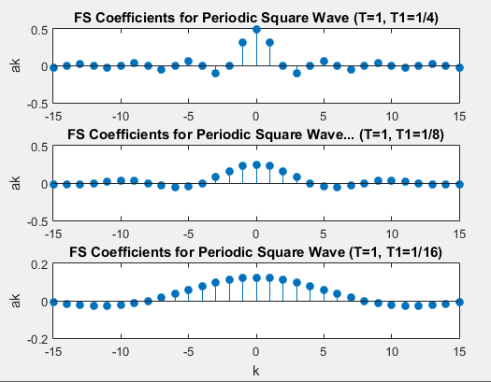

**Task # 4:**

Considering the plots of square wave reconstructed using M = 10, 20, & 100 terms above, what do you observe about Gibb’s phenomenon?

**Observation:**

As the number of signals to be added increases from 10 to 100 the square wave smoothens in form and is more defined.

**Code:**

t = -1.5:0.005:1.5; %square wave duration

T = 1; %time period of square wave

T1 = 1/4; %duty cycle of square wave

w0 = 2*pi/T; %fundamental radian frequency of square wave

M = 100; %number of coefficients

k = -M:M; %2M+1 total coefficients to construct square wave

ak = sin(k*2*pi*(T1/T))./(k*pi);

ak(M+1) = 2*T1/T; % Manual correction for a0 ?> ak(M+1)

x = zeros(1,length(t));

for k = -M:M

x = x + ak(k+M+1)*exp(j*k*w0*t);

end

plot(t,x,'lineWidth',2);

grid;

xlabel('t');

ylabel('x(t)');

title('Reconstruction from Fourier Series');

**Output:**

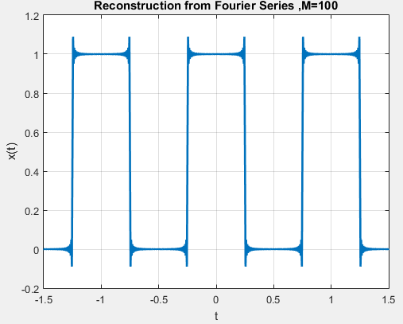 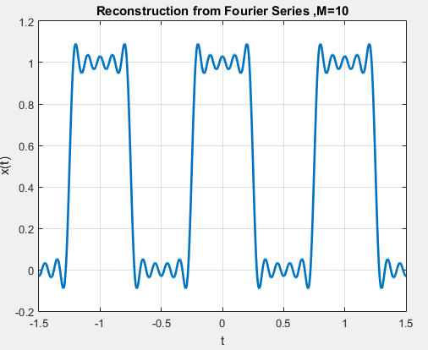

**Task # 5:**

Given the following FS coefficients:



Plot the coefficients & reconstructed signal. Take the terms for reconstructed signal to be

M = 10, 20, & 50. What effect do you see when M is varied?

**Observation:**

As the number of signals to be added increases from 10 to 60 the wave smoothens in form.

**Code:**

t = -2:0.005:2; %square wave duration

T = 1; %time period of square wave

T1 = 1/4; %duty cycle of square wave

w0 = 2*pi/T; %fundamental radian frequency of square wave

M = 60; %number of coefficients

x = zeros(1,length(t));

for k = -M:M; %2M+1 total coefficients to construct square wave

if(mod(k,2)==0)

ak = 1;

x = x + ak*exp(j*k*w0*t);

else

ak = 2;

x = x + ak*exp(j*k*w0*t);

end

end

plot(t,x,'lineWidth',2);

grid;

xlabel('t');

ylabel('x(t)');

title('Reconstruction from Fourier Series, M=60');

**Output:**

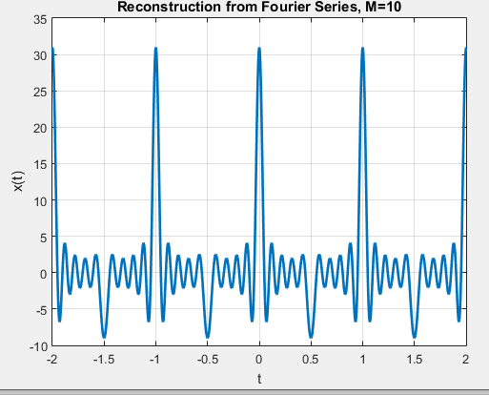 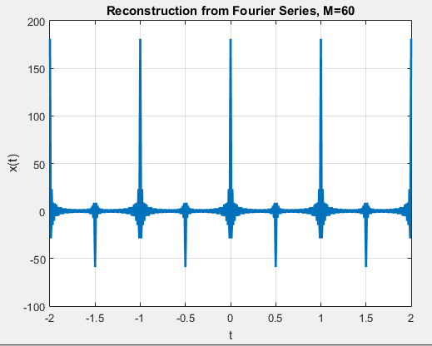

**Task # 6:**

Given the following FS coefficients:

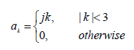

Plot the coefficients & reconstructed signal. Take 10 terms (M=10) for reconstructed signal.

**Problem Analysis:**

Take M equal to 10 and plot the signal.

**Code:**

t = -5:0.005:5; %square wave duration

T = 1; %time period of square wave

T1 = 1/4; %duty cycle of square wave

w0 = 2*pi/T; %fundamental radian frequency of square wave

M = 10; %number of coefficients

x = zeros(1,length(t));

for k = -M:M; %2M+1 total coefficients to construct square wave

if(abs(k)< 3)

ak = j*k;

x = x + ak*exp(j*k*w0*t);

else

ak = 0;

x = x + ak*exp(j*k*w0*t);

end

end

plot(t,x,'lineWidth',2);

grid;

xlabel('t');

ylabel('x(t)');

title('Reconstruction from Fourier Series, M=10');

**Output:**

